Periodontal Disease

Periodontal disease is the most common diseases in companion animals. Despite this, it remains an under-recognized condition and treatment is often under-utilized. The periodontal tissues (periodontium) are the tissues that support the tooth in the mouth. Periodontal disease is characterized by inflammation of these tissues, which subsequently leads to tissue destruction and loss.
Periodontal disease (PD) occurs in response to plaque bacteria. Like in people, plaque is the living film (biofilm) that forms on the surfaces of the teeth every day. The body's immune system recognizes these plaque bacteria and local inflammation in the mouth occurs. This initial inflammation always starts at the gum (aka gingiva) and is referred to as gingivitis. Gingivitis is completely reversible with profession care and consistent home care. If left untreated, gingivitis will often progress to periodontitis. Periodontitis is inflammation of the periodontal tissues below the gum. It is characterized by loss of the gingival attachment and bone surrounding the tooth. With periodontitis and attachment loss, pockets around the teeth form. The pockets that form below the gumline provide a place for more bacteria to live. Inflammation in response to bacteria sitting within the pockets below the gumline further contributes to bone and tissue loss. Eventually, periodontitis will become irreversible. Pain, infection, abscesses, tooth loss, and in severe cases, jaw fracture may occur.
Initial Signs
The most common reported clinical symptom of periodontal disease is halitosis (bad breath). Doggy breath is not normal! Halitosis is a hallmark of periodontal disease. Caretakers also may report that their pet is not eating well. Occasionally, pets may drool, or blood may be noted in the saliva. Pet owners may also report that a pet paws at his mouth. Upon oral examination, red, inflamed gingiva may be noted. The gingiva may bleed easily on probing and there is usually an accumulation of plaque and calculus (aka tartar).
Staging Periodontal Disease
General anesthesia is needed for complete evaluation. During the examination, each area around the tooth is explored with a periodontal probe. The periodontal probe measures the depth of pockets and tissue loss around the teeth. Dental x-rays also assess for any periodontal tissue loss around the teeth. The classification system used here uses a system of Stage 1 through Stage 4.
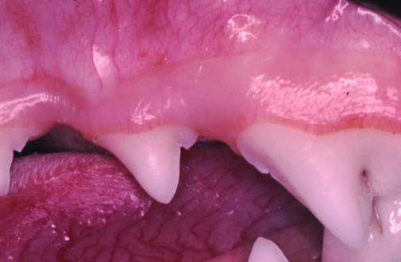
Stage 0 - NORMAL
Clinically normal and healthy - no gingival inflammation or periodontitis clinically evident. Gingival tissue is firm. With close observation tiny blood vessels can be seen out to the margins.
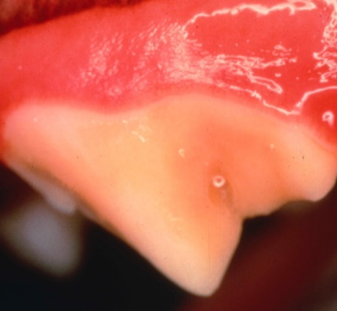
Stage 1 - GINGIVITIS
Variable amounts of plaque/calculus and mildly reddened gums (gingivitis). This stage is usually reversible but will progress without treatment.

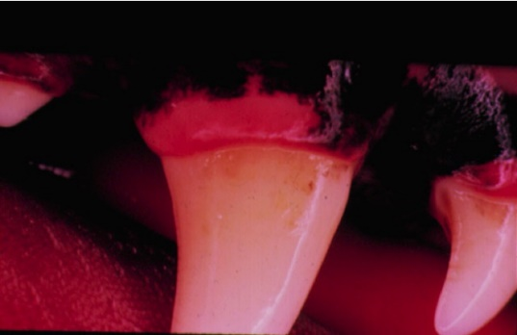
Stage 2 - MILD
Larger amounts of plaque and calculus accumulation are seen. Gingivitis and bleeding gums are seen, and early periodontal pockets can be noted. These patients typically have bad breath. Periodontal changes may be irreversible.
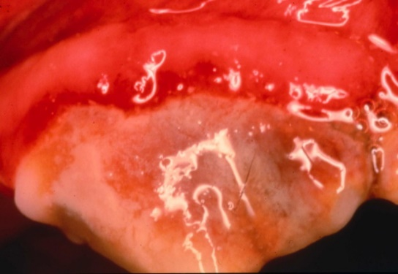
Stage 3 - MODERATE
Significant gingivitis and bone involvement is present. Teeth are becoming mobile as moderate calculus, gum recession, and gingival pockets are also noted. Irreversible tooth damage may be present, and these patients often require advanced periodontal therapy or oral surgery.

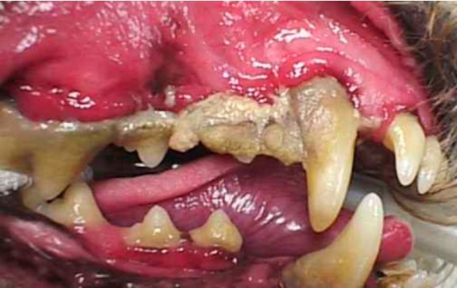

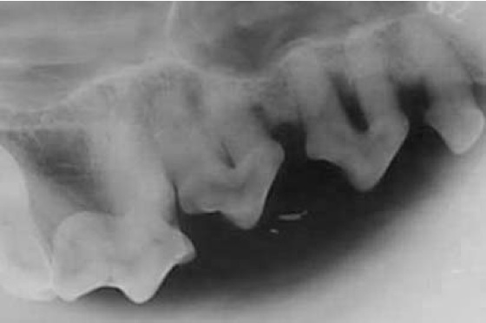
Stage 4 - SEVERE
Teeth have advanced breakdown of support tissues with severe pocket depth. Signs include severe calculus accumulation, dead tissue with blood and pus, severe halitosis, significant bone loss, and mobility of teeth. Patients require tooth extractions and oral surgery.

Systemic Effects
The systemic effects associated with periodontal disease are well documented in humans. Studies in people have shown association between periodontal disease and diabetes mellitus, pulmonary disease, heart disease, low term fetal birth weight, early term fetal birth, and others. Research in veterinary medicine is still ongoing. The theory is that bacteria and inflammatory mediators from infected oral tissues enter the bloodstream. Distant organs such as the lungs, kidney and heart may be susceptible to this dissemination of within the bloodstream.
Factors that Contribute to Periodontal Disease
There are many factors that determine why one patient is afflicted with periodontal disease while another is not. These include age, species, breed, genetics, chewing behavior, diet, grooming habits causing impaction of hair around the tooth, orthodontic occlusion, general patient health status, home care, frequency of professional dental care, and bacterial flora of the oral cavity.
Treatment
Periodontal disease therapy should be individualized to the patient depending on several factors including the severity of the disease, willingness and ability of the owner to provide home care, breed of the animal, health status of the animal, and frequency of professional dental care.

Tooth Root Abscesses
Tooth root abscesses and facial swelling are most often seen with chronic cases of periodontal disease or when a fractured tooth leads to infection in the surrounding tissues.
Dental x-rays allow us to fully evaluate the condition. Treatment depends on the cause and the extent of the disease.
